GET DATA FROM NODE AND EXPORT HTML

1. Run by file script

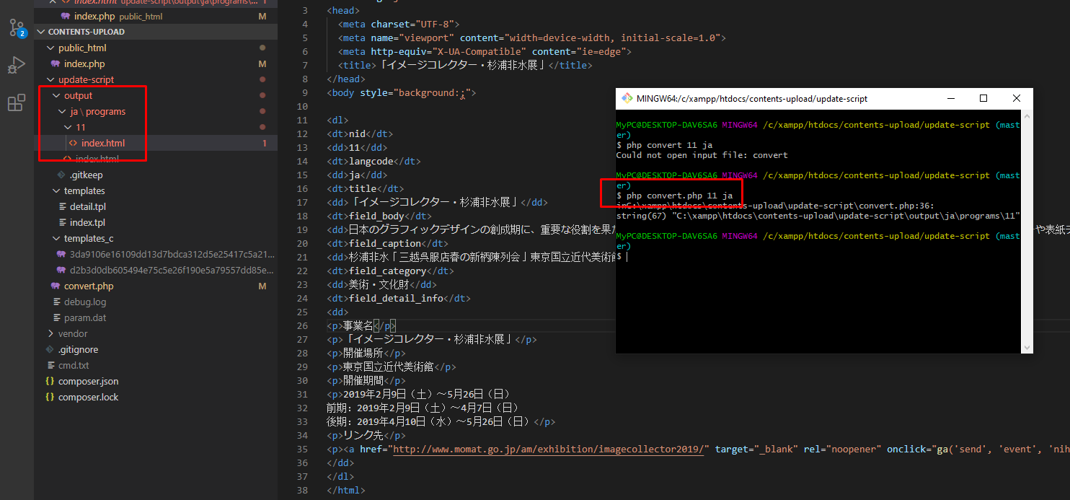

* Run the file convert.php with 2 parameters, nid and language
* From sample template/detail, we will get the html file containing the data node get from the two parameters passed.

1. Run on http:

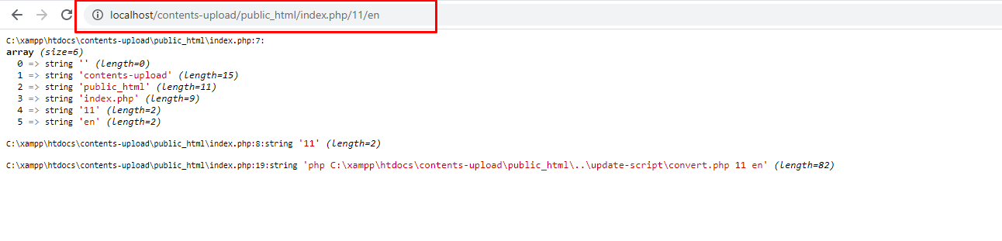

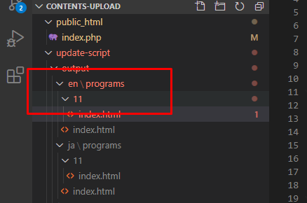

* When you run the index file, you may need to change number array of path to get correct id and language because this has a different url structure
* The result run as script file